TOPIC 4: DYNAMIC PROGRAMMING
1.
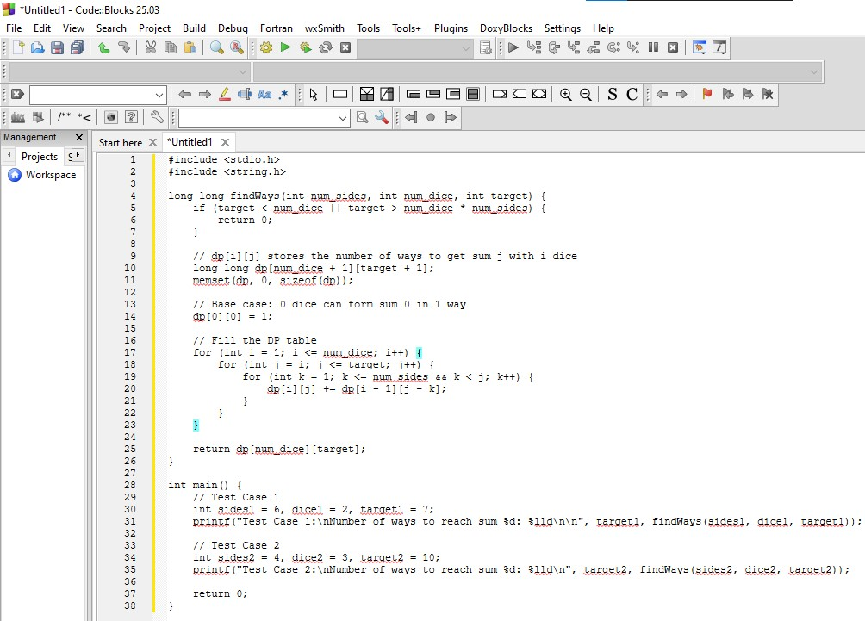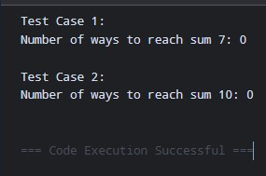
Time Complexity: $O\left(\text{num_dice}×\text{target}×\text{num_sides}\right)$|
Space Complexity: $O\left(\text{num_dice}×\text{target}\right)$

2.
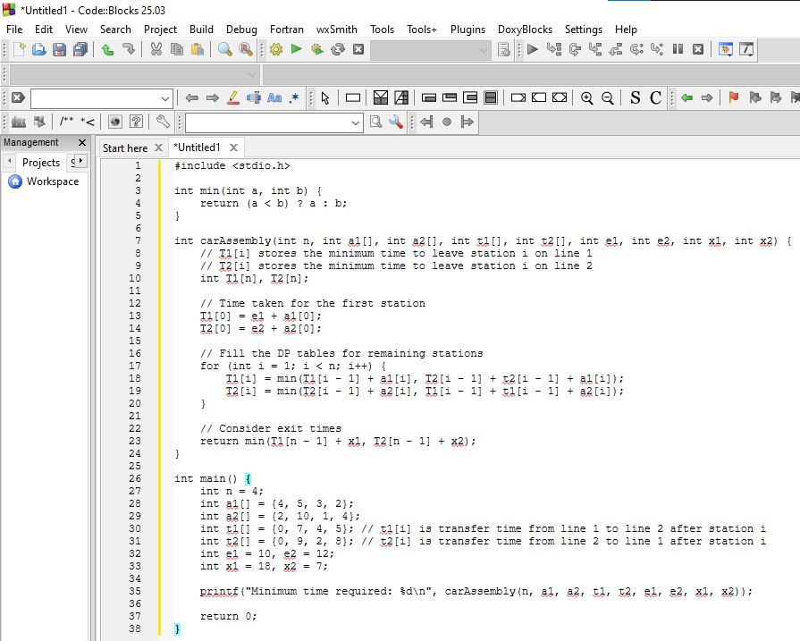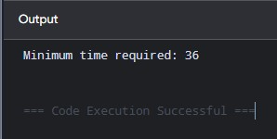
Time Complexity: $O\left(n\right)$
Space Complexity: $O\left(n\right)$

3.
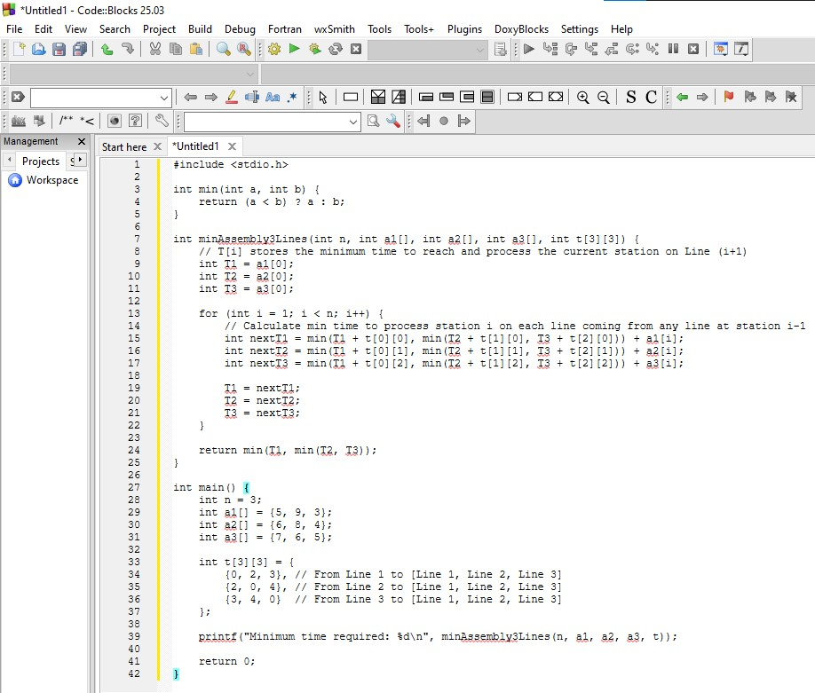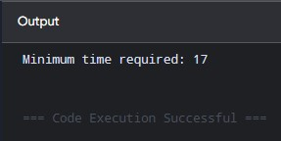
Time Complexity: $O\left(n×L^{2}\right)$ where $L=3$ is the number of assembly lines
Space Complexity: $O\left(1\right)$

4.
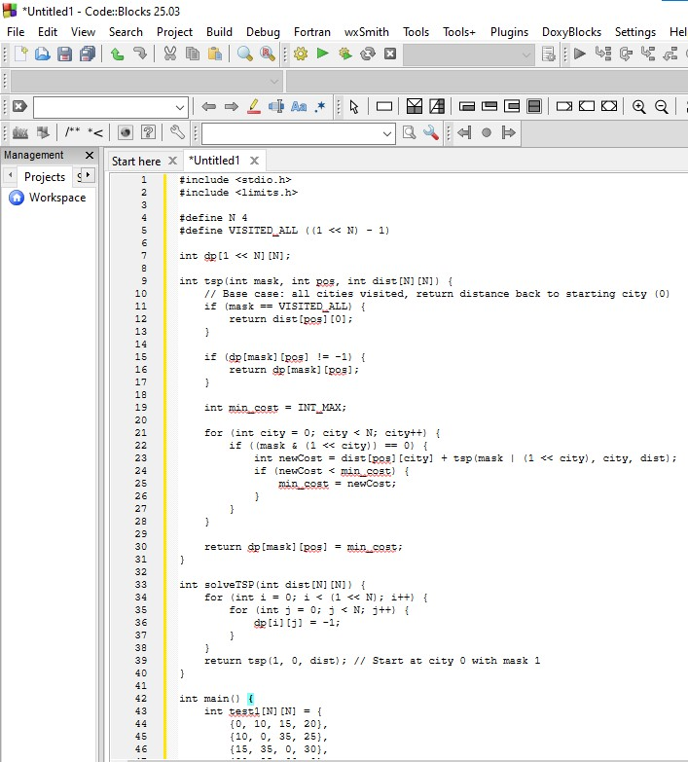
Output:
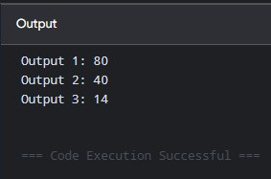
Time Complexity: $O\left(N^{2}⋅2^{N}\right)$
Space Complexity: $O\left(N⋅2^{N}\right)$

5.
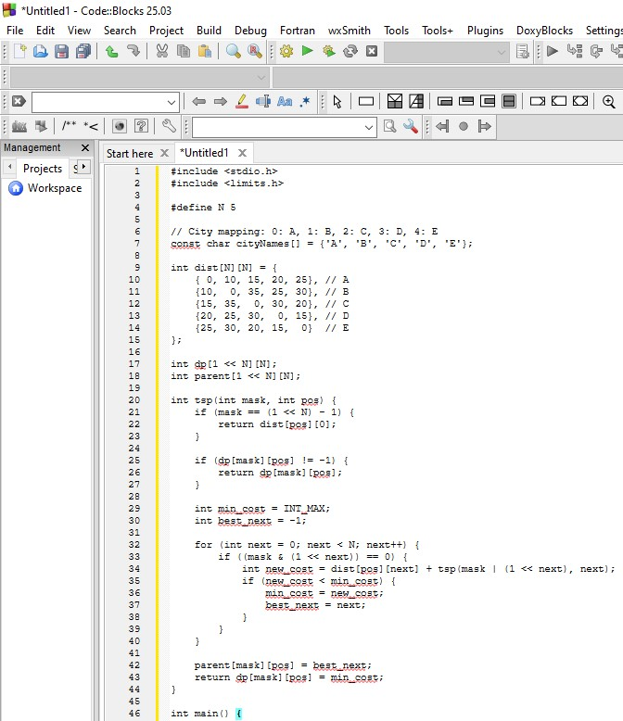
Output:
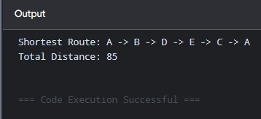

Time Complexity: $O\left(N^{2}⋅2^{N}\right)$
Space Complexity: $O\left(N⋅2^{N}\right)$

6.
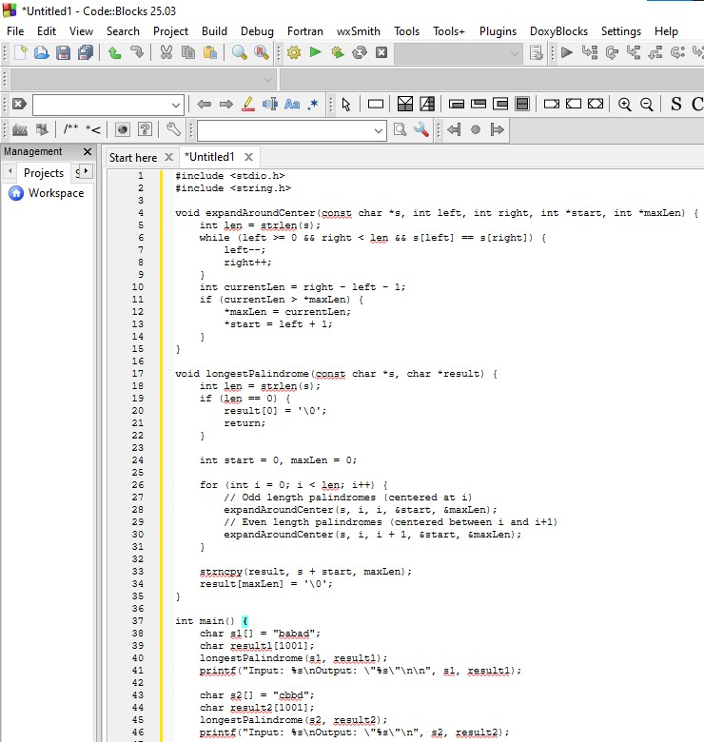
Output:
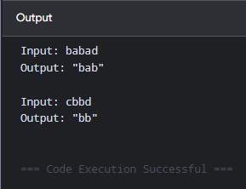
Time Complexity: $O\left(N^{2}\right)$
Space Complexity: $O\left(1\right)$

7.
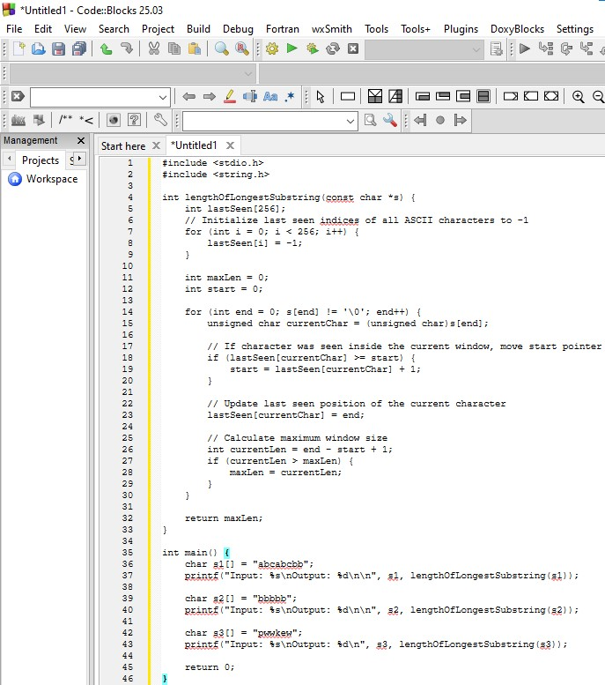
Output:
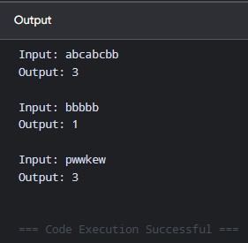
Time Complexity: $O\left(N\right)$
Space Complexity: $O\left(1\right)$

8.
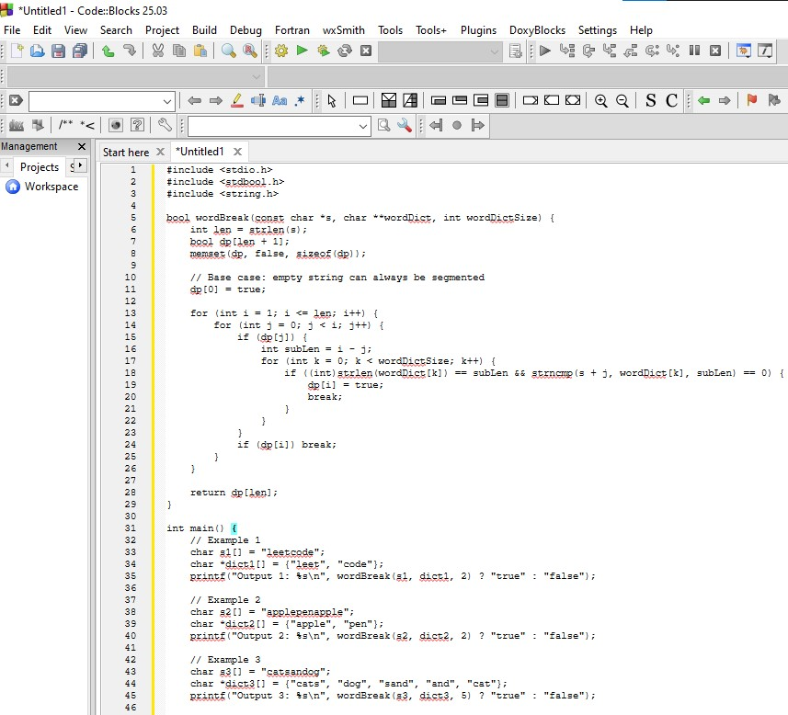
Output:
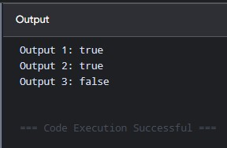
Time Complexity: $O\left(N^{2}⋅M⋅K\right)$
Space Complexity: $O\left(N\right)$

9.
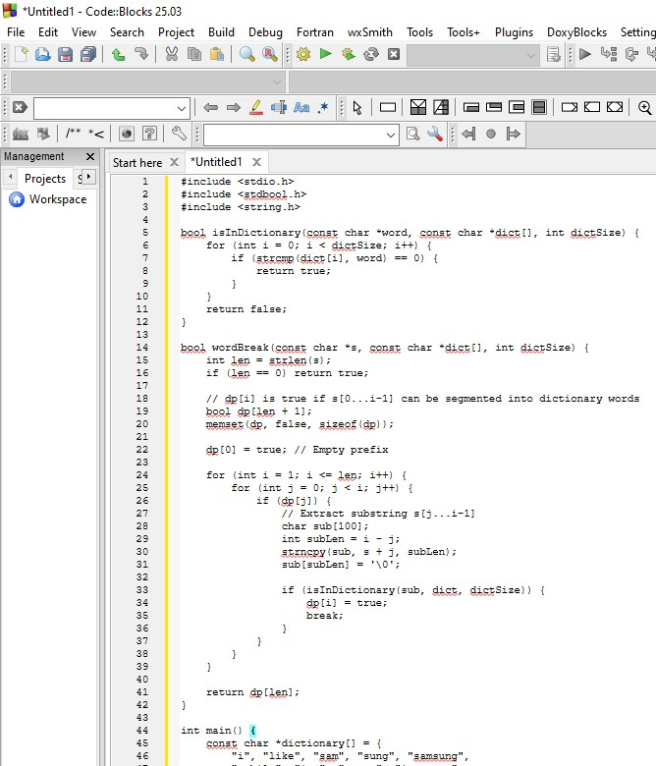
Output:
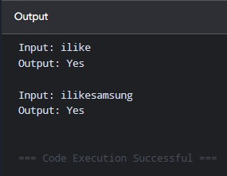
Time Complexity: $O\left(N^{2}⋅M⋅K\right)$
Space Complexity: $O\left(N\right)$

10.
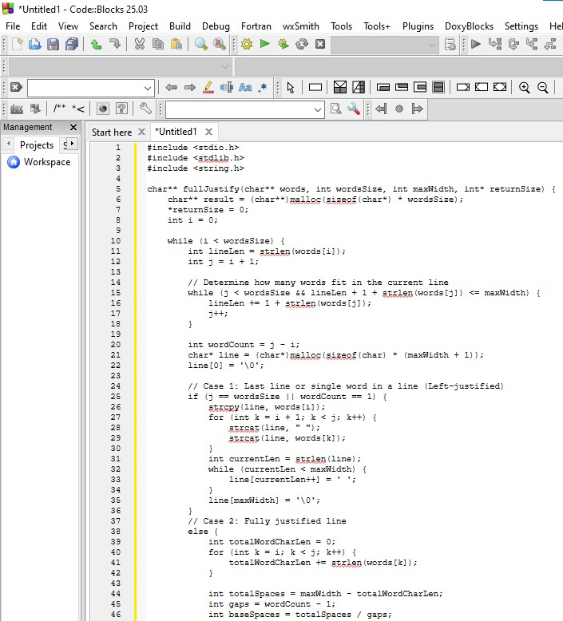
Output:
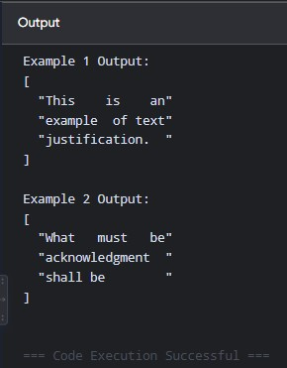
Time Complexity: $O\left(N⋅\text{maxWidth}\right)$
Space Complexity: $O\left(N⋅\text{maxWidth}\right)$

11.
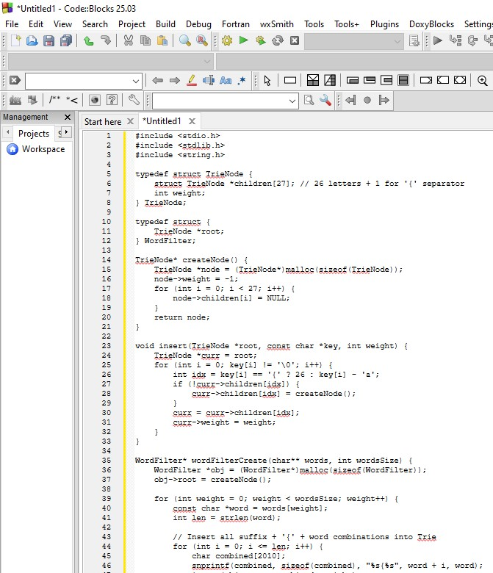
Output:
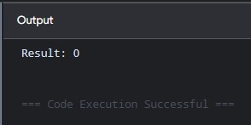
Time Complexity: $O\left(N⋅L^{2}\right)$ initialization, $O\left(P+S\right)$ per query (where $N$ is total words, $L$ is max word length, $P$ is prefix length, $S$ is suffix length)
Space Complexity: $O\left(N⋅L^{2}⋅Σ\right)$ where $Σ=27$

12.
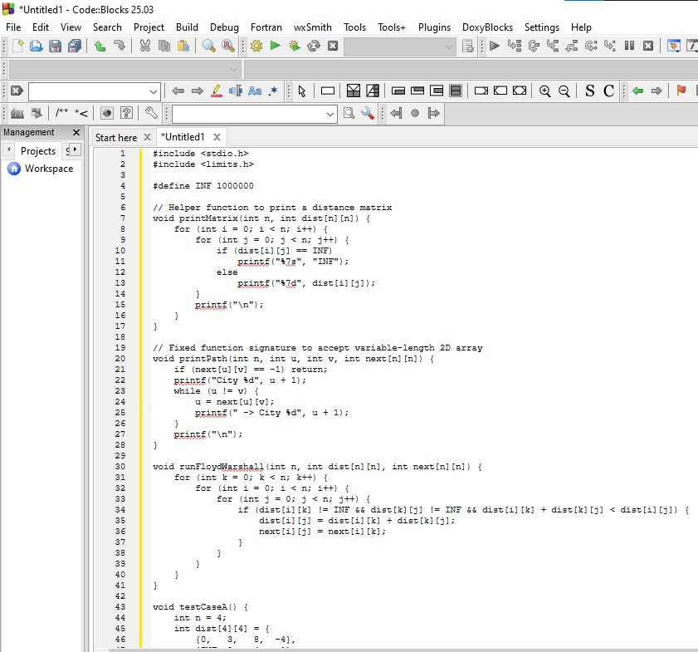
Output:
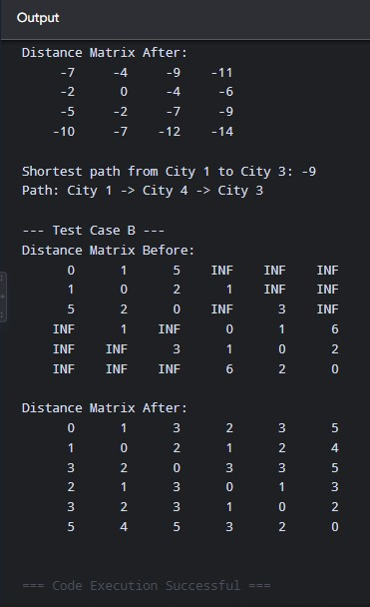
Time Complexity: $O\left(V^{3}\right)$
Space Complexity: $O\left(V^{2}\right)$
13.
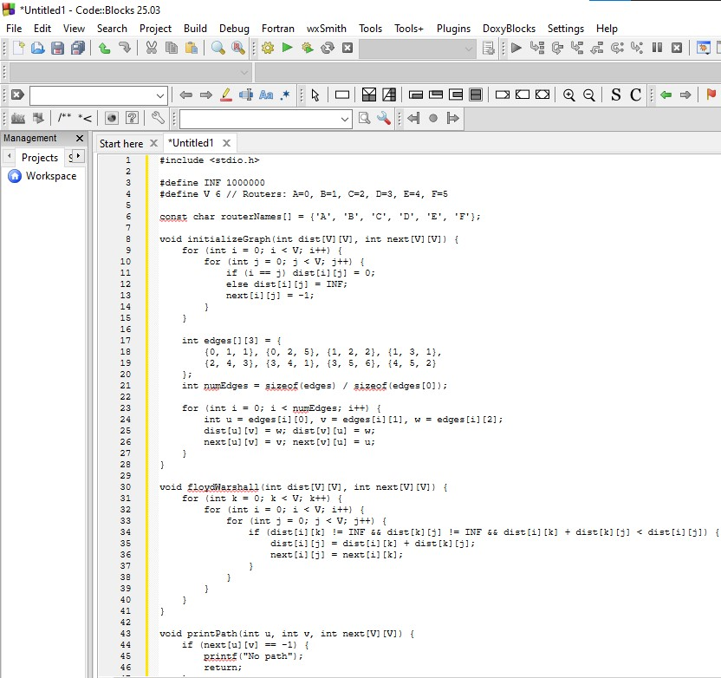
Output:
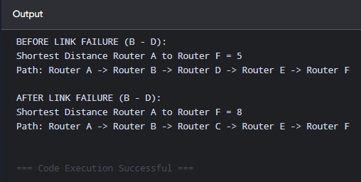
Time Complexity: $O\left(V^{3}\right)$
Space Complexity: $O\left(V^{2}\right)$

14.
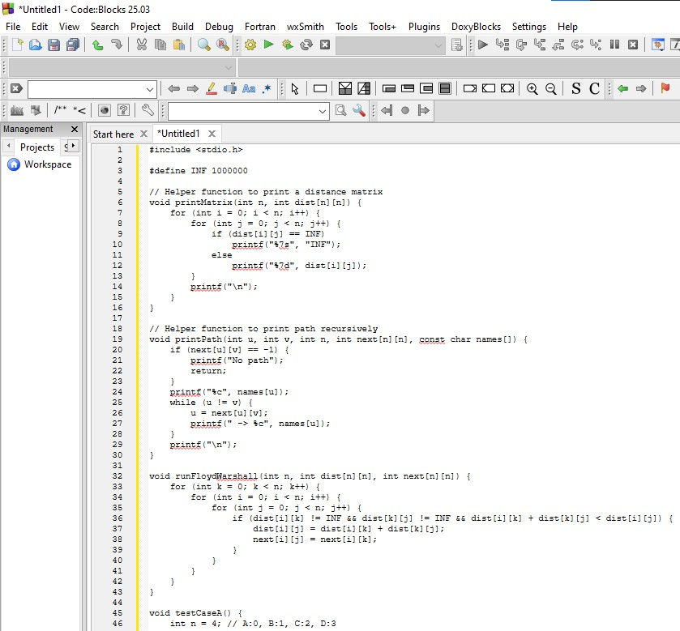
Output:
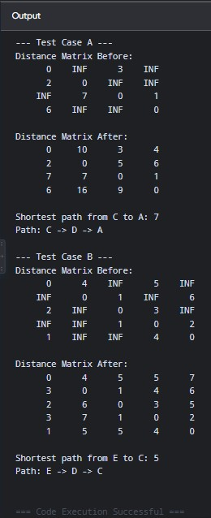
Time Complexity: $O\left(V^{3}\right)$
Space Complexity: $O\left(V^{2}\right)$
15.
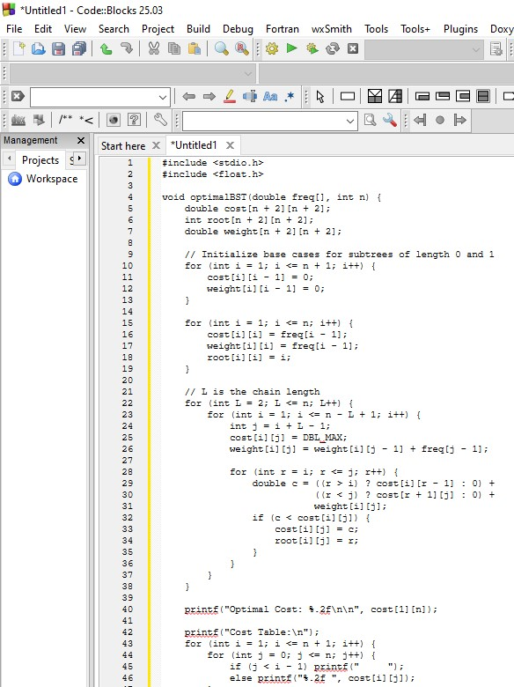
Output:
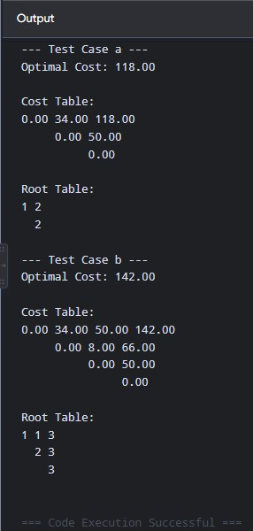
Time Complexity: $O\left(N^{3}\right)$
Space Complexity: $O\left(N^{2}\right)$
16.
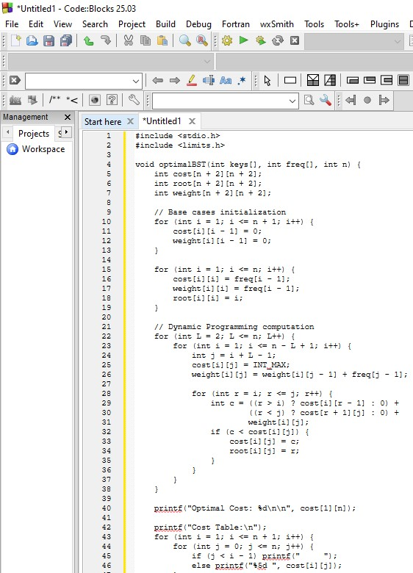
Output:
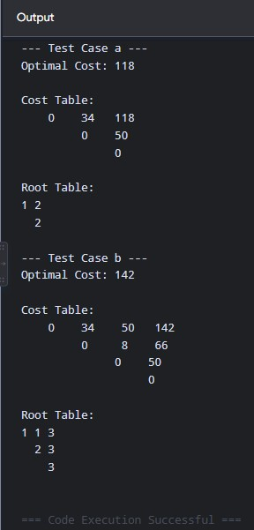
Time Complexity: $O\left(N^{3}\right)$
Space Complexity: $O\left(N^{2}\right)$
17.
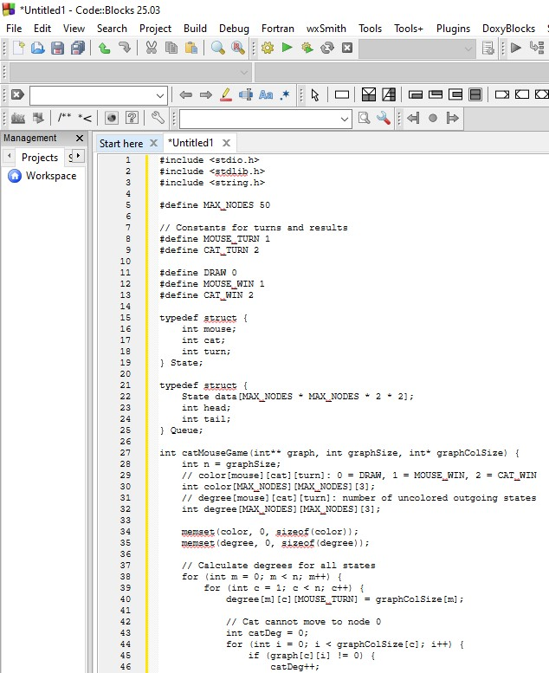
Output:
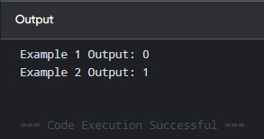
Time Complexity: $O\left(V⋅E\right)$ where $V$ is number of nodes and $E$ is total edges
Space Complexity: $O\left(V^{2}\right)$

18.
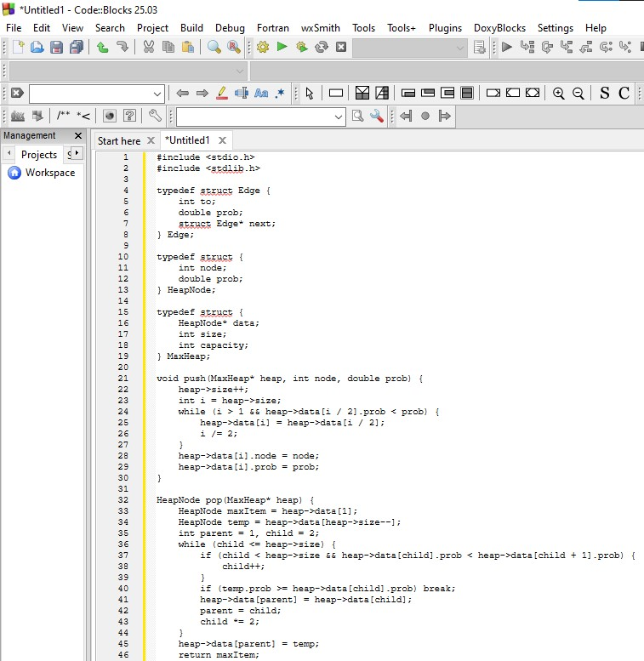
Output:
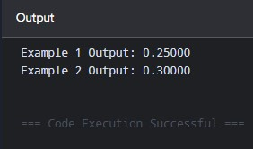
Time Complexity: $O\left(E\log{V}\right)$
Space Complexity: $O\left(V+E\right)$

19.
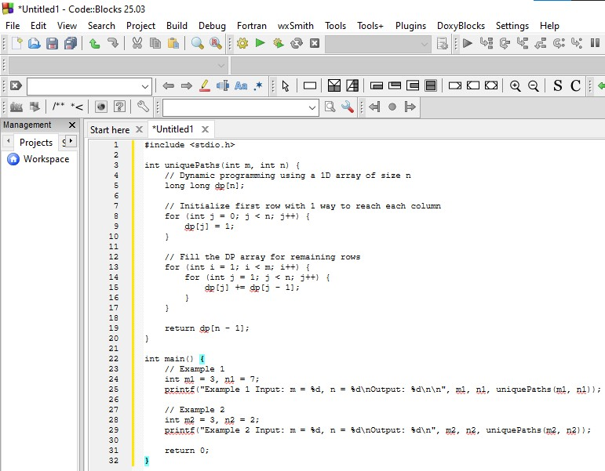
Output:
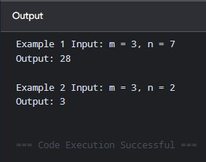
Time Complexity: $O\left(m×n\right)$
Space Complexity: $O\left(n\right)$

20.
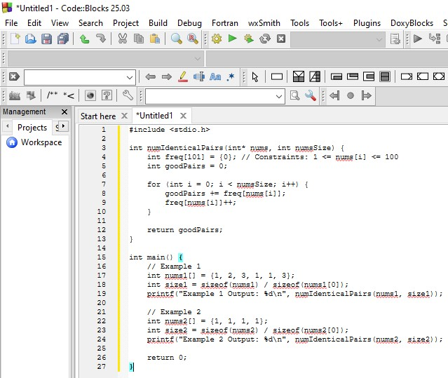
Output:
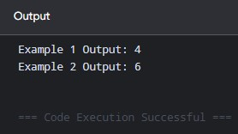
Time Complexity: $O\left(N\right)$
Space Complexity: $O\left(1\right)$

21.
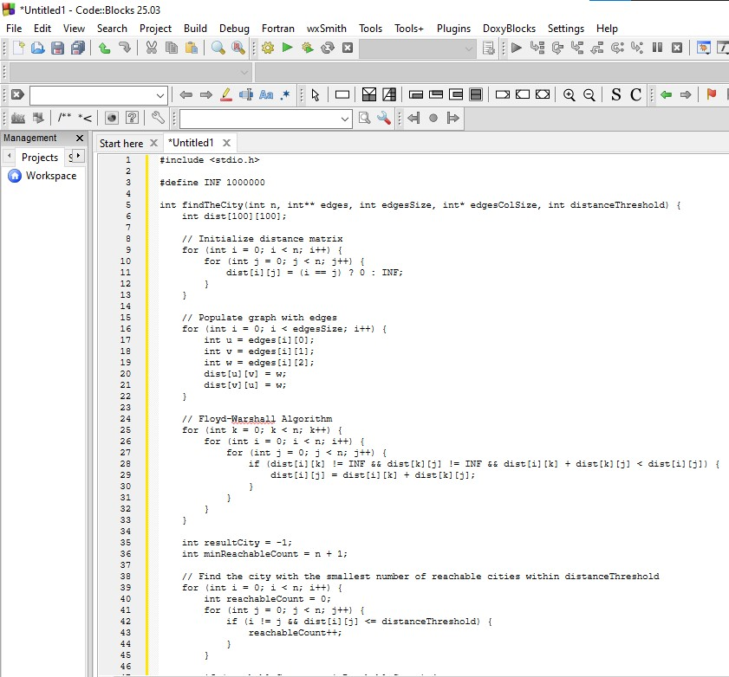
Output:
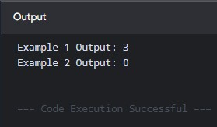
Time Complexity: $O\left(N^{3}\right)$
Space Complexity: $O\left(N^{2}\right)$

22.
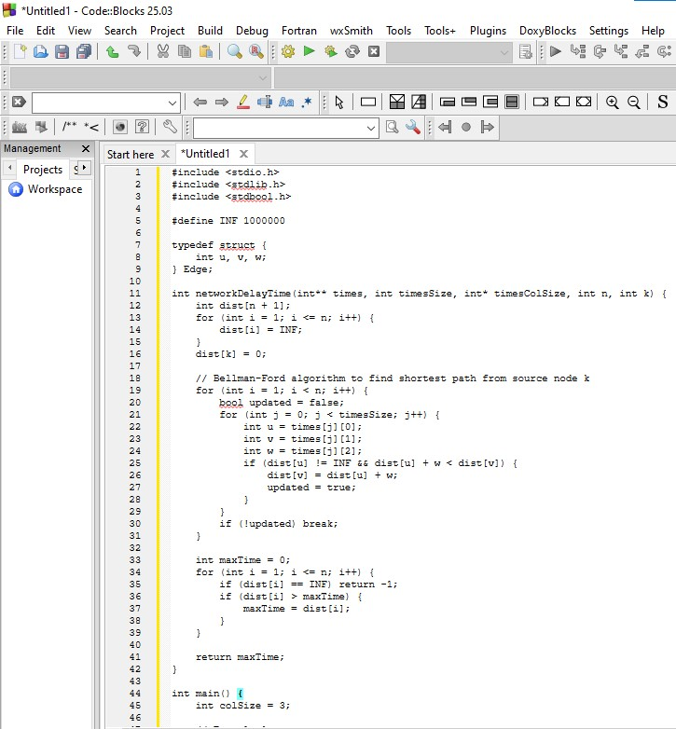
Output:
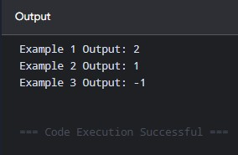
Time Complexity: $O\left(V⋅E\right)$
Space Complexity: $O\left(V\right)$

